Benjamin Linam

[Bml42@students.uwf.edu](mailto:Bml42@students.uwf.edu)

EEL 4744L: Microprocessor Applications Laboratory

Lab 4: Writing and Testing a Simple Program

2/19/2018

**Objective**

Introduce students to writing and testing a program in HC11 assembly language and using the BUFFALO I/O routines to display/verify the results.

**Introduction/Background/Theory**

This lab required construction of an assembly program which would count the number of entries in an N-byte array to determine if each number was positive, negative, even, and/or odd. Provided for the lab was a list of numbers to be stored in memory starting at location $100. The value “N” was the number of entries in the array and was utilized by the program to determine how many values it should test.

**Procedure**

1. Starting at memory location $00, the assembly language code allocates memory to store how many even/odd and positive/negative numbers are in the N-byte array.

2. The array of numbers provided during lab for testing is then saved into memory starting at $100.

3. Program execution begins at $B600 with setting each count variable to zero as to prevent any residual values stored in memory from skewing the results.

4. Accumulator X is then loaded with the location of the first value in the array and added to the value of accumulator B to increment through the array.

5. Using BRCLR and BRSET, each number is tested to determine if it is positive or negative or even or odd. If the least significant bit (LSB) is 1, the number is odd, while if it is 0, the number is considered even. Similarly, if the most significant bit (MSB) is 1, the number is negative, while if it is 0, it is positive.

6. After testing each number, the individual counters are incremented and the loop is repeated with the next value in the array. If the last element has been evaluated, the program escapes the loop and terminates.

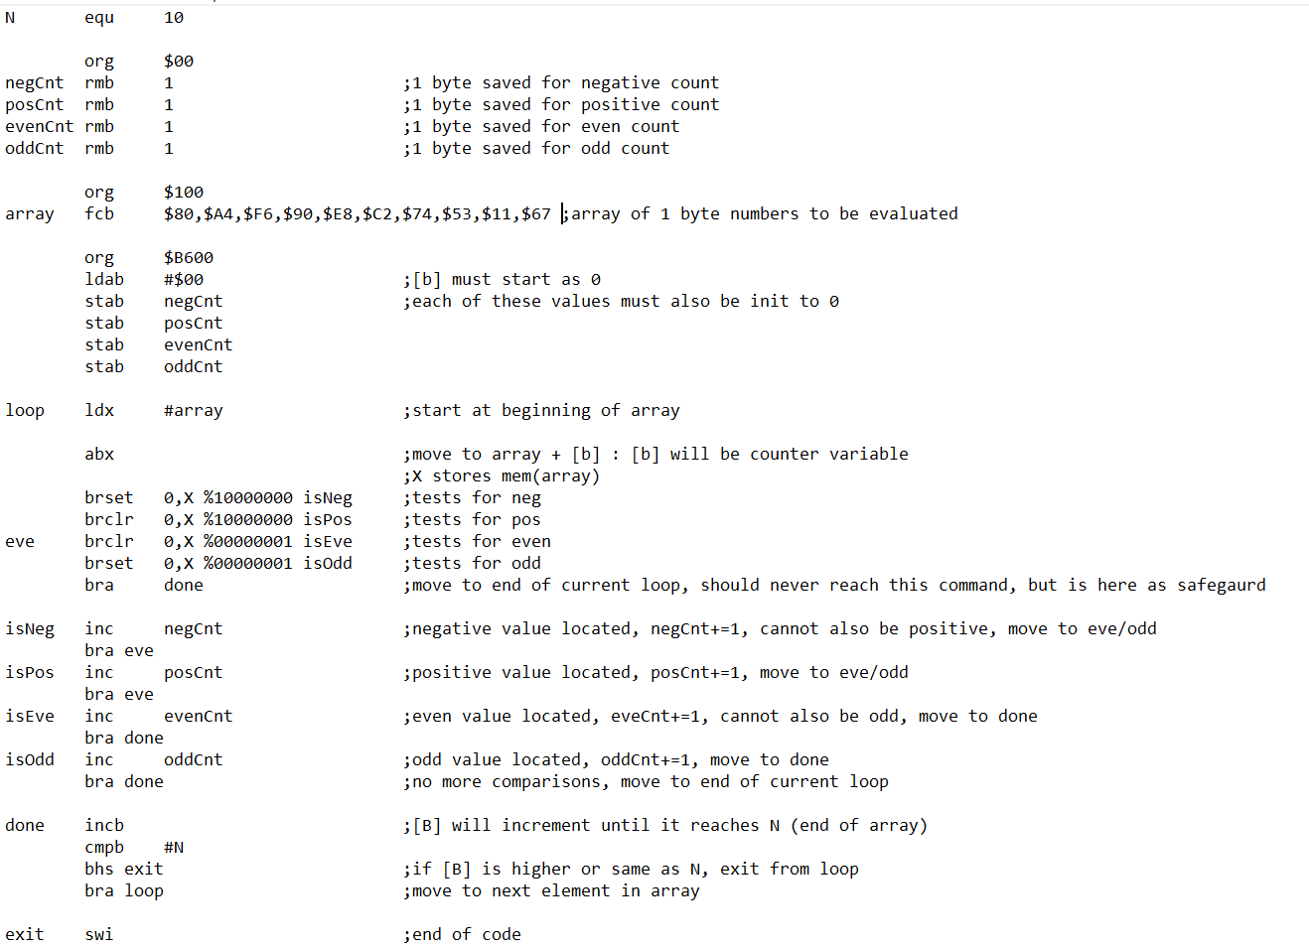

**Figure 1**: Assembly language code designed to evaluate the total number of positive/negative and even/odd elements in an N-byte array.

7. After running the program using the BUFFALO I/O command “G B600” (B600 being the location of the starting byte of the program’s code), the individual counts will be saved from memory locations $00-$03. The values will be saved in the following order: negative count, positive count, even count, and odd count. Entering the command “MD 00 1” displays memory locations $00-$0F to enable all four values to be viewed at once.

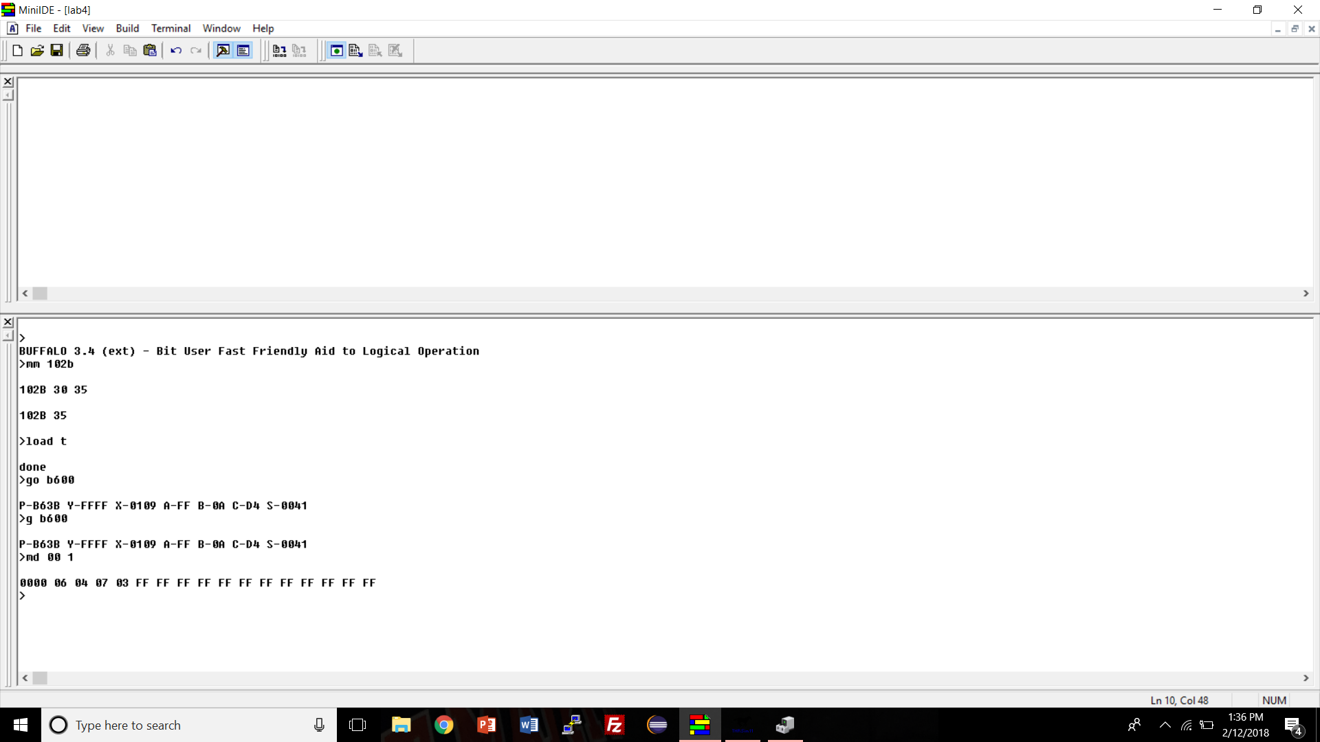

**Figure 2**: Memory locations $00-$0F after evaluating elements stored in array.

**Conclusions**

The program and lab were completed quickly and efficiently. The only problem encountered while coding the program, was incorrect usage of a 4-bit mask for BRCLR and BRSET instead of 8-bits which must be included to test each number.